OMNICHANNEL AI E-COMMERCE MARKETING
FORECASTER & OPTIMIZER

Table of Contents
Table of Contents 1
1. Executive Summary 1
Problem Statement 1
Existing Challenges 1
Proposed Solution 1
Expected Benefits 1
2. Introduction 1
3. Problem Statement 1
4. Objectives 1
5. Proposed Solution 1
6. Overall System Architecture 1
Predictive Campaign Data Input 1
Data Ingestion Layer 1
Data Standardization & KPI Engine 1
Time-Series Forecasting Engine 1
AI Strategy Synthesis Layer 1
Output Layer 1
Enterprise Security & Compliance 1
7. Working Principle 1
8. Functional Modules 1
Intelligent OmniChannel Data Ingestion 1
Cross-Channel Performance Matrix 1
Predictive Portfolio Optimization Engine 1
Probabilistic Risk & Volatility Guardrails 1
9. Technology Stack 1
10. KPI Calculations 1
11. Strategic Recommendations 1
Portfolio Health Verification 1
Risk & Volatility Mitigation 1
Attribution Scaling Optimization 1
12. Advantages 1
13. Conclusion 1

OMNICHANNEL AI E-COMMERCE MARKETING
FORECASTER & OPTIMIZER

Problem Statement
Modern e-commerce enterprises deploy significant capital across highly fragmented advertising platforms, including Google Ads, Meta Ads, and Bing Ads. Data attribution models for these platforms typically exist in isolated data silos, which prevents marketing executives from calculating a true, unified view of their overall marketing efficiency.

Existing Challenges
As a consequence of this fragmentation, businesses experience substantial capital waste due to delayed budget optimization and human mathematical error when campaign budgets are scaled manually across multiple platforms.

Proposed Solution
The OmniChannel AI E-commerce Marketing Forecaster & Optimizer addresses this fragmentation by functioning as a unified ingestion and diagnostic intelligence layer. The application provides a schema-agnostic interface that instantly aggregates raw, multi-platform performance CSV exports. By applying automated schema identification, real-time portfolio balancing, volatility tracking, and large language model (LLM) analytical frameworks, the system enables marketing teams to move from speculative, reactive budget adjustment toward proactive, risk-managed predictive simulation.

Expected Benefits
The system is expected to eliminate manual computation errors, consolidate multi-channel performance visibility into a single interface, and provide risk-aware, forecast-driven guidance for future budget allocation decisions.

2. Introduction
Businesses operating in the e-commerce sector deploy advertising budgets across multiple platforms such as Google Ads, Meta Ads, and Bing Ads simultaneously. Managing multi-platform marketing is inherently difficult because each platform reports performance data using its own format, terminology, and metrics structure, making it difficult to compare performance across channels in a consistent manner.
Isolated advertising platforms create data silos because attribution models and reporting structures for Google Ads, Meta Ads, and Bing Ads are not designed to interoperate. This isolation prevents marketing executives from obtaining a true, unified view of overall marketing efficiency, since performance figures from each platform must be manually reconciled before a comparison can be made.
A unified analytics layer is therefore necessary to consolidate these disparate data sources into a single, standardized view. Without such a layer, marketing teams are limited to reactive, platform-by-platform assessments rather than a holistic understanding of portfolio performance.
Predictive forecasting is useful because it allows marketing teams to move beyond historical reporting and instead anticipate future performance outcomes under different budget allocation scenarios. This shifts decision-making from speculative, reactive budget adjustment toward proactive, risk-managed planning.

3. Problem Statement
The core problems addressed by this project, as identified in the project specification, are as follows:
- Fragmented Advertising Data: Performance data for Google Ads, Meta Ads, and Bing Ads exists in isolated data silos, preventing a unified view of marketing efficiency.
- Manual Budget Allocation: Marketing budgets are scaled manually across platforms, which is time-consuming and does not scale with growing campaign complexity.
- Human Mathematical Errors: Manual calculation of budget allocations and performance metrics is prone to human mathematical error.
- Delayed Optimization: Because budget adjustments are performed reactively, optimization of campaign spend is delayed rather than proactive.
- Lack of Unified Performance Visibility: The absence of a consolidated reporting layer prevents marketing executives from viewing true, blended performance across all channels simultaneously.

4. Objectives
- To provide a unified ingestion mechanism for multi-channel advertising CSV exports from Google Ads, Meta Ads, and Bing Ads through automated schema detection.
- To standardize disparate platform-specific metrics into normalized tracking parameters, namely date, spend, revenue, and channel.
- To calculate cross-channel key performance indicators, including platform-specific Return on Ad Spend (ROAS) and the Global Blended Baseline ROAS.
- To enable predictive portfolio optimization through real-time budget allocation simulation, with a strict 100% portfolio ceiling to eliminate over-allocation errors.
- To forecast future campaign performance with a 90% confidence interval visualization that represents best-case and worst-case volatility bounds.
- To generate AI-driven strategic recommendations, culminating in an Executive Strategy Brief, using a causal reasoning module built on large language model (LLM) analysis.

5. Proposed Solution
The proposed solution operates as an end-to-end pipeline that begins with raw CSV upload and concludes with the generation of an AI-synthesized marketing strategy. The complete workflow proceeds as follows:
- The user uploads one or more raw performance CSV exports from Google Ads, Meta Ads, and/or Bing Ads through a flexible multi-file drag-and-drop interface.
- A custom parsing script dynamically inspects the header metadata of each uploaded file to identify its source platform: Google Ads fields such as segments_date and metrics_cost_micros, Meta Ads fields such as date_start and conversion fields, and Bing Ads fields such as TimePeriod and Spend. A generic fallback layer handles arbitrary custom schemas.
- Once identified, all inputs are standardized into normalized tracking columns: date, spend, revenue, and channel.
- The Data Standardization & KPI Engine computes platform-specific metrics for Google, Meta, and Bing, along with the Global Blended Baseline ROAS (total combined revenue divided by total combined spend).
- The user inputs a future ad budget target and allocates budget share across channels using real-time UI sliders, which are constrained by a strict 100% portfolio ceiling to prevent over-allocation.
- The Time-Series Forecasting Engine generates a dynamic timeline plot of projected performance, wrapped in a 90% Confidence Corridor to represent uncertainty bounds.
- The AI Strategy Synthesis Layer assembles prompt context from the forecasted and historical data and applies a causal reasoning module to generate logical, data-driven strategic recommendations.
- The Output Layer compiles the results into an Executive Strategy Brief for stakeholder review.

6. Overall System Architecture
Figure 1 shows the overall architecture of the OmniChannel AI E-commerce Marketing Forecaster & Optimizer, illustrating the flow of data from multi-channel CSV ingestion through to the generation of the Executive Strategy Brief.
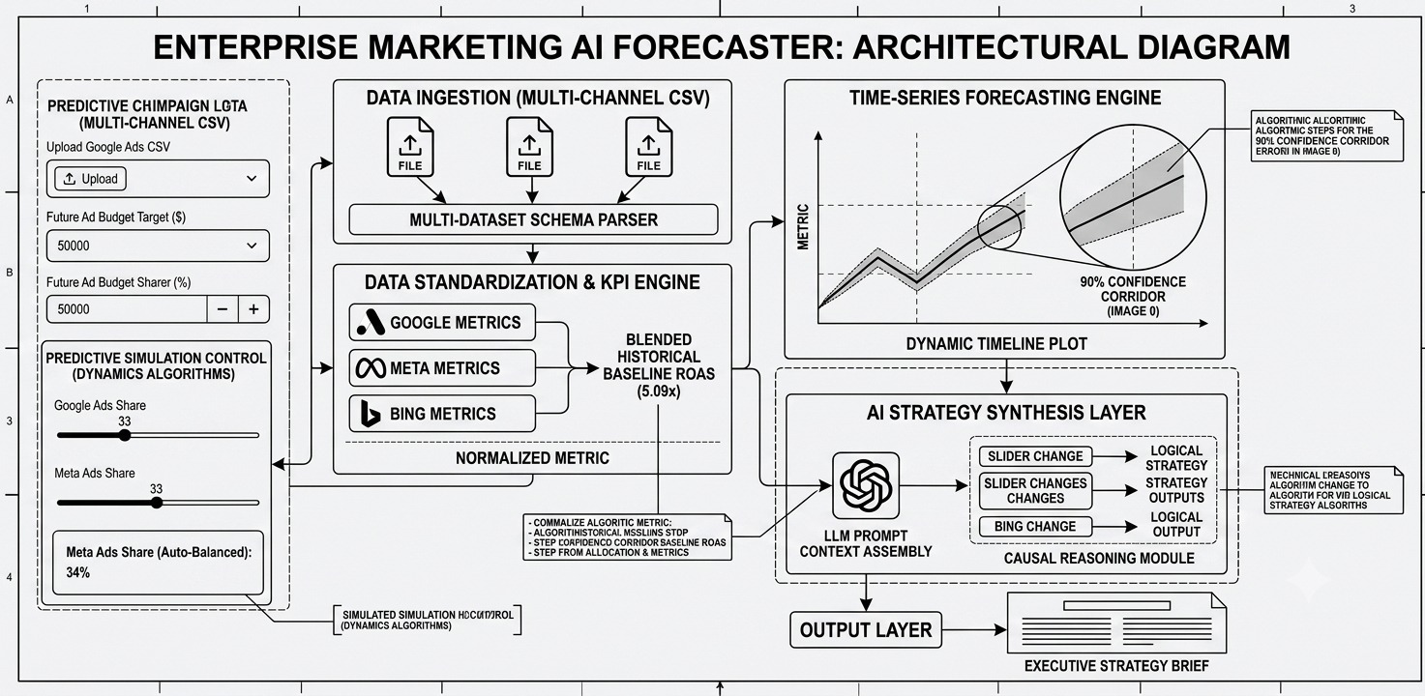
Figure 1. Overall System Architecture
The architecture is composed of a sequence of functional blocks, each of which is explained individually below.

Predictive Campaign Data Input
This block allows the user to upload the Google Ads CSV, specify a future ad budget target, and set the budget share allocation across channels. Predictive simulation controls, including per-channel share sliders operating under dynamic algorithms, allow the user to model campaign scenarios.

Data Ingestion Layer
This layer accepts multi-channel CSV uploads and passes them through a multi-dataset schema parser, which dynamically detects the dataset type of each uploaded file so that it can be routed to the correct standardization logic.

Data Standardization & KPI Engine
This engine processes Google metrics, Meta metrics, and Bing metrics individually, converting each into normalized metrics. These normalized metrics are then combined to compute the Blended Historical Baseline ROAS, which serves as the historical performance baseline against which forecasted returns are compared.

Time-Series Forecasting Engine
This engine generates a forecast of future performance along a dynamic timeline. The forecast is presented with a 90% confidence corridor, which visually represents the range of best-case and worst-case outcomes around the expected trend.

AI Strategy Synthesis Layer
This layer performs prompt context assembly, drawing on the normalized metrics, blended baseline ROAS, and forecast outputs. A causal reasoning module then processes changes such as slider adjustments and budget-related changes to synthesize logical strategy outputs and recommendations.

Output Layer
The Output Layer compiles the results of the AI Strategy Synthesis Layer into an Executive Strategy Brief, which forms the final deliverable presented to the user.

Enterprise Security & Compliance
To align with enterprise production engineering guidelines, the application isolates its analytical core logic from public network dependency vulnerabilities. The system architecture supports the official google-genai SDK natively. When deployed in live corporate production environments, API authentication keys are managed externally via secure local environment variables (GEMINI_API_KEY) to prevent accidental exposure in public version control repositories such as GitHub.

7. Working Principle
The complete workflow of the system proceeds as the following sequence of steps:
- Step 1 — CSV Upload
- Step 2 — Automatic Schema Detection
- Step 3 — Data Standardization
- Step 4 — KPI Calculation
- Step 5 — Portfolio Optimization
- Step 6 — Forecast Generation
- Step 7 — AI Strategy Generation
- Step 8 — Executive Report

8. Functional Modules

Intelligent OmniChannel Data Ingestion
Rather than restricting users to a fixed layout or rigid filenames, the application features a flexible multi-file drag-and-drop system. Upon ingestion, a custom parsing script dynamically inspects the header metadata of each CSV file. Google Ads schema detection identifies fields such as segments_date and metrics_cost_micros to extract time-series parameters. Meta Ads schema detection scans for operational signatures such as date_start and conversion fields. Bing Ads schema detection automatically targets tracking headers such as TimePeriod and Spend. A generic fallback layer parses arbitrary custom schemas by mapping date-like and financial strings, ensuring the application remains universally data-agnostic. Once recognized, all inputs are standardized globally into normalized tracking columns (date, spend, revenue, and channel) without requiring pre-processing from the user.

Cross-Channel Performance Matrix
The platform consolidates all active pipelines to render a unified financial overview. It isolates key historical attributes by platform, calculating Total Channel Spend, Total Gross Revenue, Platform-Specific Return on Ad Spend (ROAS), and the Global Blended Baseline ROAS (total combined revenue divided by total combined spend).

Predictive Portfolio Optimization Engine
The application converts historical parameters into a dynamic simulation playground. By rendering real-time UI sliders mapped to each actively detected channel, users can model future growth campaigns by inputting target ad budgets and tracking length. To eliminate baseline mathematical errors, the optimization engine enforces a hard logic boundary: allocations are dynamically calculated against a strict 100% portfolio ceiling, locking the inputs to prevent budget over-allocation.

Probabilistic Risk & Volatility Guardrails
To prevent misleading linear growth projections, the system features a time-series volatility forecaster. Using a confidence-interval visualization matrix via Plotly, the tool wraps the expected daily target revenue line in a 90% Confidence Corridor (Uncertainty Bounds). This mapping illustrates standard market shifts and best/worst-case scenarios for executive stakeholder review.

9. Technology Stack
The application's technical stack leverages decoupled Python data engineering and rendering layers, designed for fast inference loops and extreme scalability.

Technology | Purpose
Streamlit | Web application (UI) framework — Streamlit Open-Source Core Framework.
Pandas | Vectorized data processing core for dynamic time-series simulations.
NumPy | Vectorized matrix operations supporting data processing.
Plotly Graph Objects | Data visualization engine (go.Figure) utilizing multi-trace rendering and localized continuous area fills for confidence corridor isolation.
AI Insights Synthesis Layer | Automated intelligence framework replicating advanced Large Language Model (LLM) strategic analysis based on incoming real-time runtime variables.

10. KPI Calculations
KPI | Calculation | Purpose
Blended Baseline ROAS | Total Revenue / Total Spend | Serves as the historical performance baseline against which forecasted and channel-specific returns are compared.
90% Confidence Interval | Expected Return ± Volatility Corridor | Illustrates standard market shifts and best/worst-case scenarios for executive stakeholder review.
Dynamic Auto Balancing | Σ(Channel Weights) = 100% | Enforces a hard logic boundary that locks budget inputs to prevent over-allocation and eliminate baseline mathematical errors.

11. Strategic Recommendations
The application evaluates marketing data through three core business performance pillars to demonstrate commercial viability to the evaluation panel; the specific details of these pillars are not specified in the provided documentation. The integrated analytical layer evaluates the custom multi-channel configurations designed by the user and generates immediate, actionable marketing directives, as follows:

Portfolio Health Verification
The system continuously maps global spending trends to ensure capital distributions avoid hitting channel saturation thresholds.

Risk & Volatility Mitigation
The system instantly calculates the structural runway needed to meet target returns during the specific forecast window, identifying worst-case financial floors.

Attribution Scaling Optimization
The system identifies paths to shift budgets away from low-performing channels into platforms exceeding the baseline blended ROAS, maximizing capital efficiency without running into diminishing returns.

12. Advantages
- Eliminates data silos by unifying multi-platform (Google Ads, Meta Ads, Bing Ads) advertising data into a single interface.
- Reduces human mathematical error through automated schema detection, standardization, and a strict 100% portfolio allocation ceiling.
- Shifts marketing teams from speculative, reactive budget adjustment toward proactive, risk-managed predictive simulation.
- Provides a schema-agnostic ingestion mechanism supporting Google Ads, Meta Ads, Bing Ads, and generic custom CSV formats without requiring pre-processing from the user.
- Visualizes forecast risk through a 90% Confidence Corridor, illustrating best-case and worst-case scenarios for executive stakeholders.
- Generates automated, LLM-based Executive Strategy Briefs to support stakeholder decision-making.
- Designed for fast inference loops and extreme scalability through decoupled, vectorized Python data engineering (Pandas and NumPy).

13. Conclusion
Modern e-commerce enterprises face significant challenges in managing advertising budgets across fragmented, siloed platforms such as Google Ads, Meta Ads, and Bing Ads, which leads to capital waste through delayed optimization and human mathematical error.
The OmniChannel AI E-commerce Marketing Forecaster & Optimizer addresses this problem through a unified ingestion and diagnostic intelligence layer that applies automated schema identification, real-time portfolio balancing, volatility tracking, and LLM-based analytical frameworks.
The resulting benefits include the elimination of manual computation errors, consolidated multi-channel performance visibility, and risk-aware, forecast-driven guidance for future budget allocation, generated through an automated Executive Strategy Brief.
From a business impact perspective, the system shifts marketing teams from speculative, reactive budget adjustment toward proactive, risk-managed predictive simulation, thereby supporting more efficient and reliable capital allocation across advertising channels.

